Experiments Report for Project 3
Project: Adversarial Search

Student Name: Ashish Sarode
Nano-Degree name: Artificial Intelligence Nanodegree.

Initial Study:
1. To develop understanding of how good heuristics can be developed for this game, first thing was to get good understanding of the board.

- Understanding Positions (Figure A) -
Below image shows how indices are mapped on board

- Understanding how players attack each other (Figure B)
Player 0 and Player 1 are at positions indicated by Red and Green Cells, figure shows their possible move positions and path in orange to indicate Manhattan distance between them -

- Understanding Liberties associated with each cell of the board (Figure C) -
This figure clearly shows that staying in the central area has benefit since it has more degrees of freedom -

- Distances from the central cell to different cells (Figure 5)
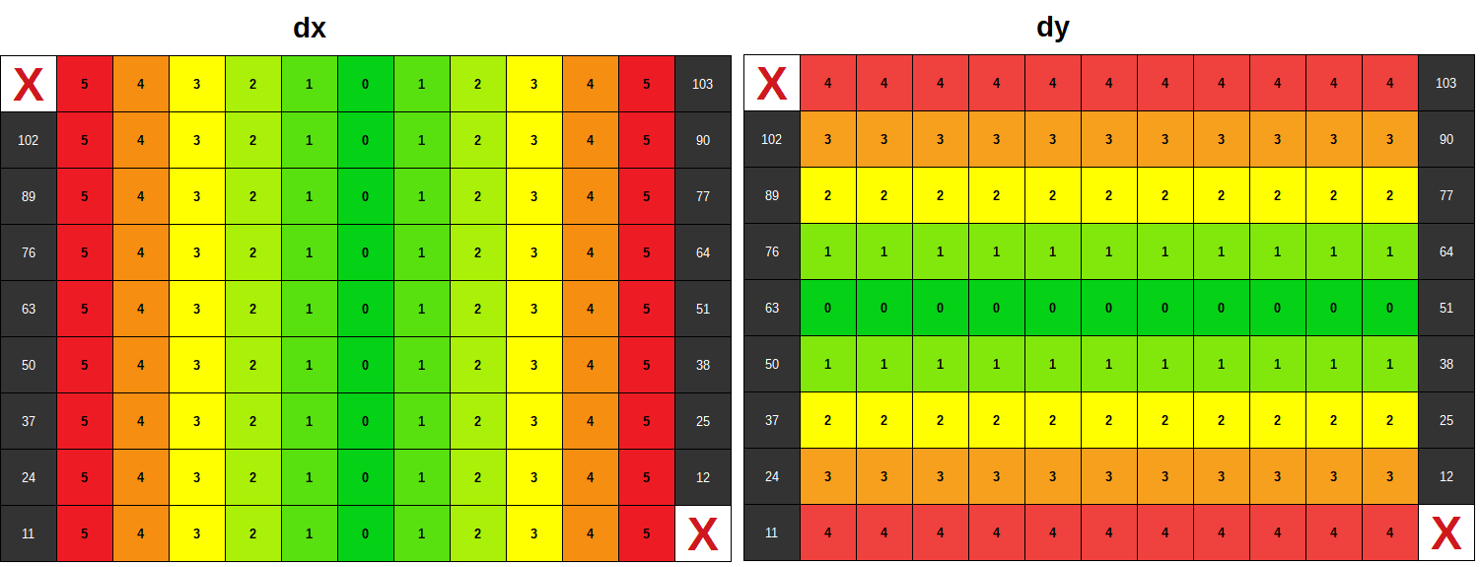
Custom Advanced Heuristic:

- Failed Based on understanding from Figure B, developed 2 heuristics which work like -
IntersectionLiberties = Common liberties between our player and opponent player.
Score = OwnLiberties – IntersectionLiberties
This means, we want to avoid positions which intersect with the opponent.
Result: Bad results
This heuristic did not perform well.
Tried other combinations like
Score = OwnLiberties – (Intersection Liberties + OpponentLiberties)/2
This and all other similar trials all gave bad results.

- Failed Tried combinations based on distances based on understanding developed from figure C and D-
E.g. Distance from opponent, distance from center etc.
Did not get much success on it.
Result: Bad results

- ** Winner Penalty for based on distance from walls and corners based on understanding developed from figure C and D -

Score = BaseHeuristic – 0.25 for each second level cell from wall
Score = BaseHeuristic – 0.50 for each first level cell from wall
This means for wall corners we have -1.0 subtracted from base heuristic and so on.
Final formula is:
score = OwnLiberties – OpponentLiberties – DistancePenalty

Result: Good results

I have used iterative deepening along with the alpha-beta search. This improves the base heuristic play itself to very good winning rates. Achieving additional improvements are difficult from here.
Without Iterative deepening (only alpha beta search)
Opponent | Base Heuristic Win % | Custom Heuristic Win % | Improvement
Random Player | 92.5 | 92.5 | 0
Greedy Player | 67.5 | 75 | 7.5
Minimax Player | 46.2 | 55 | 8.8

With Iterative deepening
Opponent | Base Heuristic Win % | Custom Heuristic Win % | Improvement
Random Player | 97.5 | 97.5 | 0
Greedy Player | 90 | 95 | 5
Minimax Player | 73.8 | 77.5 | 3.7

Depth Effect on Winning %ge (for custom heuristic)
Opponent | Without iterative deepening | With iterative deepening | Improvement
Random Player | 92.5 | 97.5 | 5
Greedy Player | 75 | 90 | 15
Minimax Player | 55 | 73.8 | 18.8

Analysis of results for custom heuristics
1. For random player it is very difficult to achieve improvement since it is already at 97.5% but at least the results are as good as the base heuristic.
2. For Greedy player there is clear improvement.
3. For minimax player, I tried playing multiple times, the improvement was about 5-10% consistently.
4. Using iterative deepening results are drastically improved, the better heuristic has less advantage when search depth is increased.

What features of the game does your heuristic incorporate, and why do you think those features matter in evaluating states during search??
As explained previously, my heuristic gives more importance to staying in the area of maximum freedom and away from the minimum freedom.
Please refer Figure C and D and explanation about heuristic C.

Analyze the search depth your agent achieves using your custom heuristic. Does search speed matter more or less than accuracy to the performance of your heuristic?
From my experiments, search speed does matter compared to heuristic accuracy. This is evident from the fact that when I tried without iterative deepening, the improvement due to accurate heuristic was much more in terms of percentage, but when iterative deepening is used (more search depth is used) it seems that the benefits of accurate heuristics are diminishing with higher depth of search.
Appendix:
1. Logs of Matches without iterative deepening, base heuristic
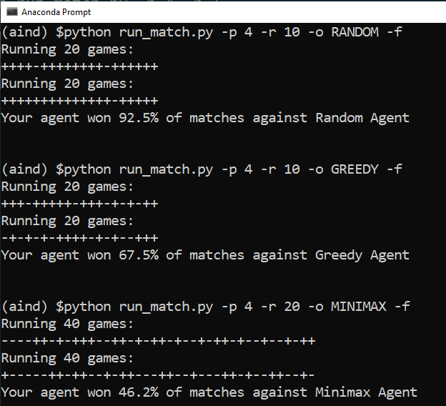

2. Logs of Matches without iterative deepening, custom heuristic
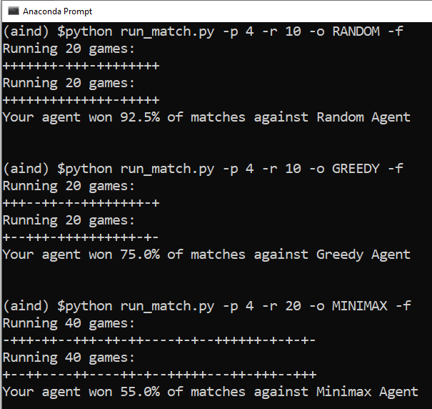

3. Logs of Matches with iterative deepening, base heuristic
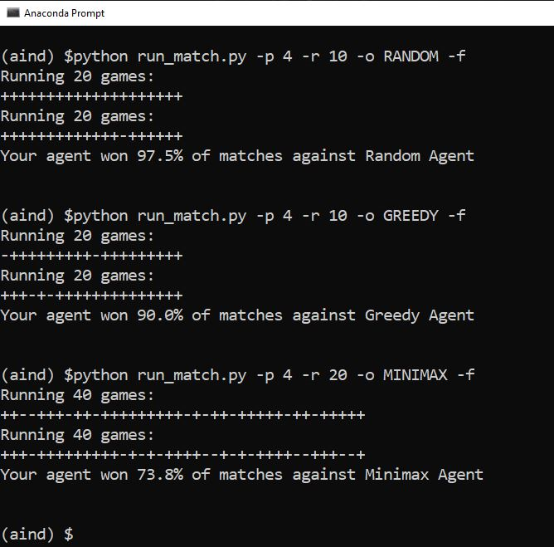

4. Logs of Matches with iterative deepening, custom heuristic
